

University of Pisa

# Brain Tumor Classifier

## An application of Deep Learning techniques for the classification of brain tumors from MRI

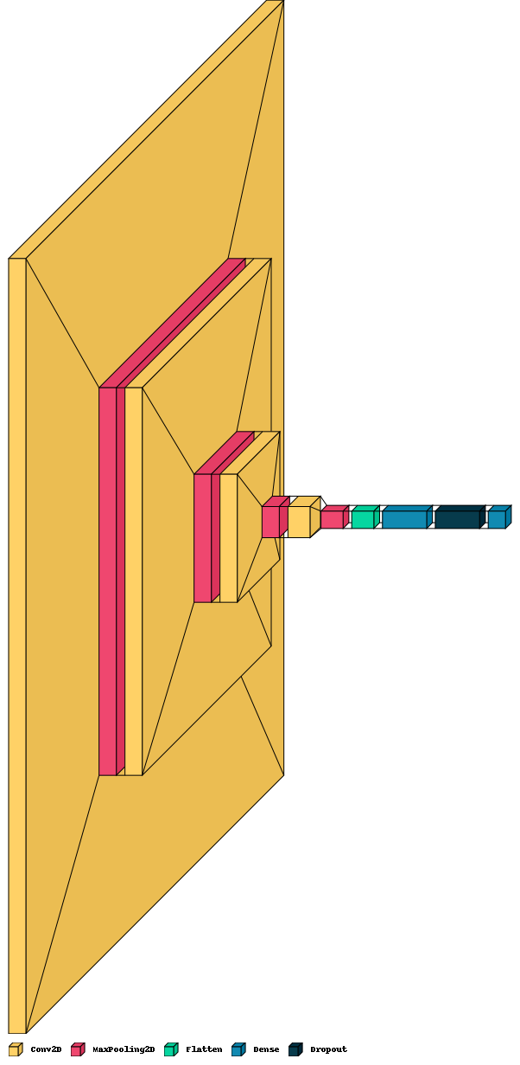

Di Donato Mattia, Giorgi Matteo

* **Topic and motivation**: the aim of our project is the classification of **Magnetic resonance imaging** (**MRI**) for the detection of brain cancer. A manual examination of MRI can be error-prone due to the level of complexities involved in brain tumors and also time consuming especially if the Neurosurgeon is not a professional, so the realization of a classifier would speed up and help doctors in the detection of this common Nervous System tumor.
* **Dataset**: the dataset taken in consideration has a dimension of 90MB and is composed by 3263 MRI divided into 4 categories: no tumor, glioma, meningioma, pituitary.

These are some images taken from it.

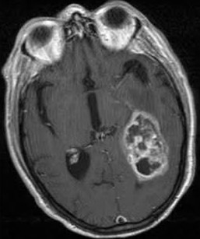

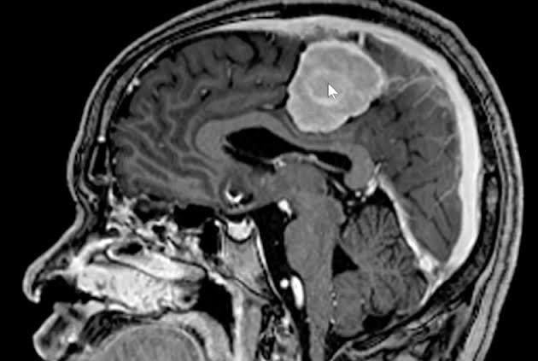

<https://www.kaggle.com/datasets/sartajbhuvaji/brain-tumor-classification-mri>

* **Task to be performed**: as we can see from the dataset, we will need to perform a preprocessing task on the images in order to make them of the same size, also data augmentation could be necessary in order to balance all the classes. After these steps we will create a CNN from scratch and we also use pretrained network like VGG or InceptionV3 making a comparison between performance of these models.